Home Innovation
Objective
This project deals with the design & development of a home security system with theft informing, fire informing and gas leakage informing features. A hardware prototype is implemented with the help of arduino controller, gas sensor, fire sensor, motion sensor and gsm module. In case of any event occurred gsm module will send a message alert to owner mobile number and activate related actuator to mitigate the problem.
Introduction
Security is a big challenge everywhere because thefts are increasing day by day owing to the unsafe and insecure security systems in homes, commercial complexes and industries. Several conventional technologies are available to keep home properties safe from intruders, but most common smart home security systems work on wireless GSM communication. Such systems provide security from natural, incidental, intended, unintended, accidental and human made problems by continuously monitoring homes with different sensory systems like motion, smoke, gas.
Block Diagram
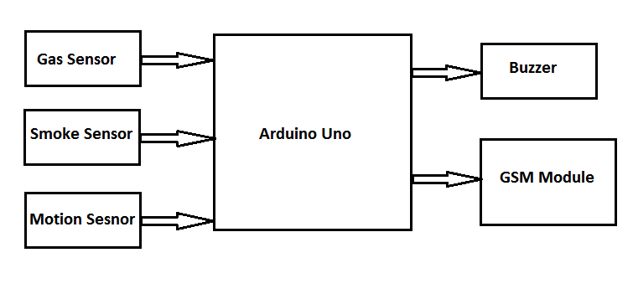

Gas Sensor
liquefied petroleum gas (LPG) sensor, suitable for sensing LPG (composed of mostly propane and butane) concentrations in the air. The MQ-6 can detect gas concentrations anywhere from 200 to 10000ppm. This sensor has a high sensitivity and fast response time.
Fire Sensor MQ2 (Smoke Sensor)
A smoke detector is an electronic fire-protection device that automatically senses the presence of smoke, as a key indication of fire.
PIR Motion Detection Sensor
Passive Infra-Red or PIR Sensor is a Pyroelectric device that detects motion. Hence, it is also called as motion detection sensor. It detects motion by sensing the changes in infrared levels emitted by nearby objects.
GSM Module (SIM 900A)
SIM 900A is the GSM/GPRS module with built in RS232 interface. It has dual band GSM/GPRS system that works on 900/1800MHz frequencies.
With the help of RS232, the modem can be connected to PC or microcontroller via serial cable. Voice calls, SMS and internet access are possible with this module.
There are on board connections for microphone and headphones with which we can make or receive calls.
Arduino UNO
It is the main controller used in this project. It detects the signals from PIR sensor and sends commands to GSM Module accordingly. The serial pins of the Arduino are used in this project to communicate with GSM module.

Component List used from ATL lab
S. No. | Component | Specifications | Qty
1 | Arduino | 8-bit processor | 1
2 | GSM Module | SIM900 | 1
3 | Resistance | 100 Ohm | 4
4 | LEDs | 5mm | 4
5 | Power Supply | 12v, 2A | 1
6 | Gas Sensor | MQ6 | 1
7 | Motion Sensor | Optical | 1
8 | Smoke Sensor | MQ2 | 1
9 | Buzzer | Piezoelectric | 1

Applications
1- Home Security: stop intrusion, gas explosion, fire
2- Motion sensor system is useful Vehicle showrooms
3- Gas leakage system is very useful in various chemical industries.
4- Fire Detection system is applicable for different offices, households, schools, industries etc.

